**[M.SALMAN]**

**[2021-SE-04]**

[OS-LAB4-Submission]



Catalog

**TASK 1 3**

**TASK 2 4**

**TASK 3 6**

**TASK 4 10**

# TASK 1

## CODE

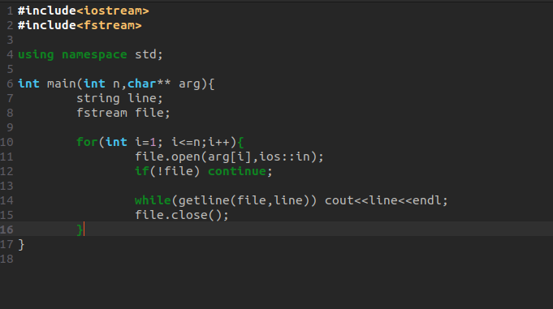

## DEMO

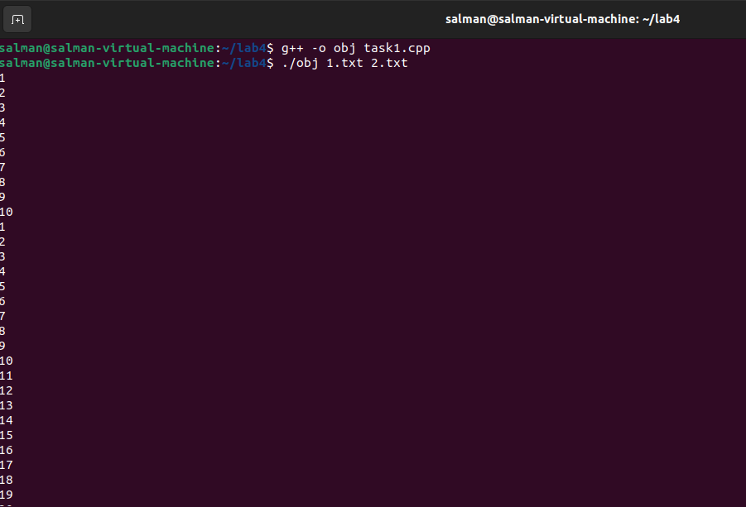

# TASK 2

## CODE

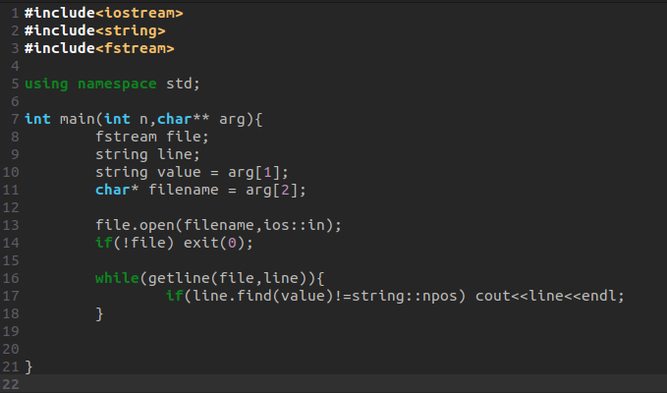

## DEMO

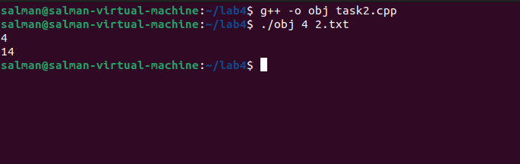

# TASK 3

## Create a file name “2021-SE-04.txt”

1. Go to directory.
2. Right click and open **Terminal.**
3. Exceute “**gedit 2021_SE_04.txt” .**
4. Now enter the text you want to add in following file.
5. Press Ctrl+S and close the file.

## 3001

## Create a filename “salman.txt”

1. Open **Terminal** in same directory.
2. Execute “**gedit salman.txt”**
3. Now enter the text you want to add in following file
4. Press Ctrl+S and close the file.

## 3002

## Merge Data of both files (2021-SE-04.txt , salman.txt)

1. Excetute “**cat 2021_SE_04 + salman.txt”.**
2. Now both content will be show in terminal.

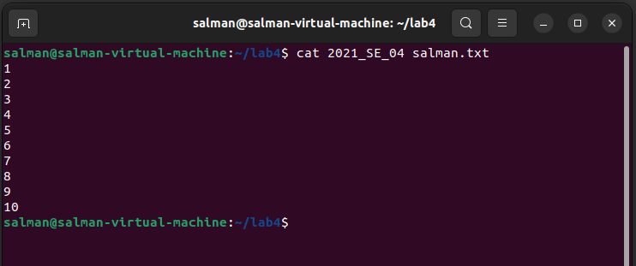

## Redirect the output

To Redirect we use “**>**”

1. Exceute **“cat 2021_SE_04 + salman.txt > merge.txt”**
2. A new merge.txt file will be create

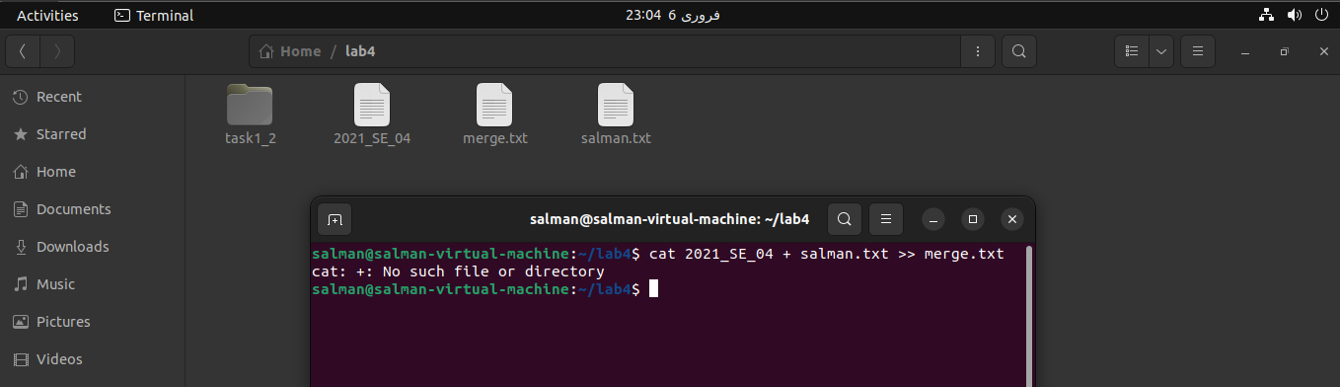

## First two lines

Exceute “**Head -2 salman.txt”,** it will display first 2 lines of the file.

## 3005

## Last two lines

Exceute “**Head -2 salman.txt”,** it will display first 2 lines of the file.

## 3006

## Finds the string

Exceute “**grep “2021_SE_04” 2021_SE_04.txt”**  it will start displaying all the line having **“2021_SE_04”**  in it . In result it is empty because there was no such line present.

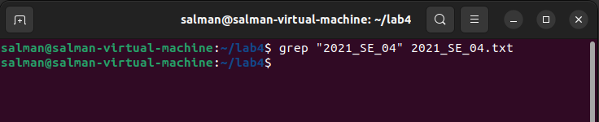

## Execute permission

Execute **chmod g+x salman.txt** to grant the execute permission of the second file to the group **.**

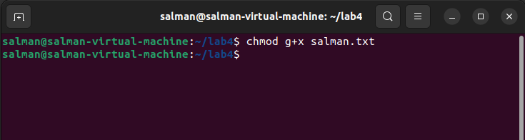

## Write permission

Execute “**chmod u-w salman.txt”** to remove the Write permission of the second file to the owner **.**

## 3009

## Current location

Exceute “**pwd”** command in terminal to get current location of present working directory.

## List of all files present in the Desktop directory

Exceute follwing two commands in given sequence:

**“cd Desktop”**

**“ls”**

## Create a folder

Excecute bellow line to make a folder in desktop

**“mkdir 2021_SE_04”**

## Display the Time.

Exceute following command to get current data time

**“date”**

## Display a thank you message

We can use **echo**  to display message on Terminal.

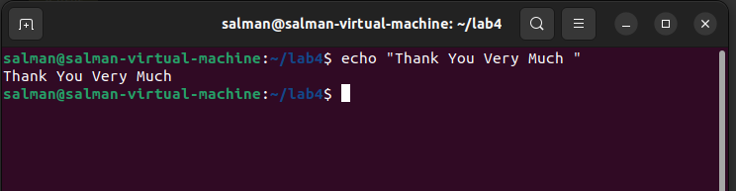

# TASK 4

1. Create a file using **Touch** command.

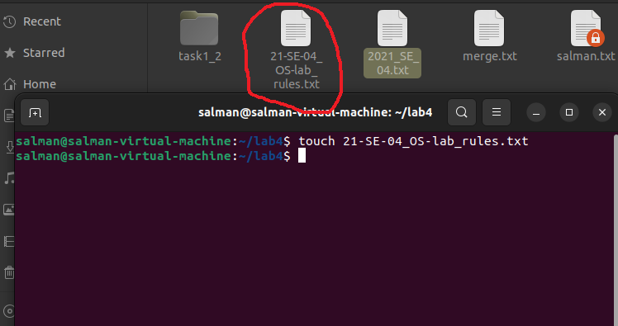

1. Now to change file Permission to “**- rwx r-x r--**” we will use the follwing rules and create a chmod command.
   * + - 1. For all Where r,w or x is present replace with 1 else 0.
         2. Now convert 3 digits binary into decimal number
         3. Here we get 7,5,4 that is our required Code
2. Exceute “**chmod 754 salman.txt**” to change the permission.

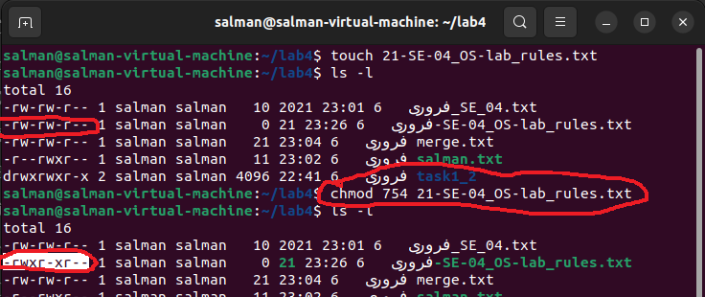

1. To appened **ls** content in the file, exceute this command “**ls >> 21-SE-04_OS-lab_rules.txt**”

